**EMPLOYEE TRACKING SYSTEM**

**BY**

**SPOTER**

A Proposal

To

**Shri. PANKAJ P DESAI.**

M/s. DESAI ASSOCIATES

*D K Park Society, Bhatar Road,*

*SURAT.*

**EMPLOYEE TRACKING SYSTEM**

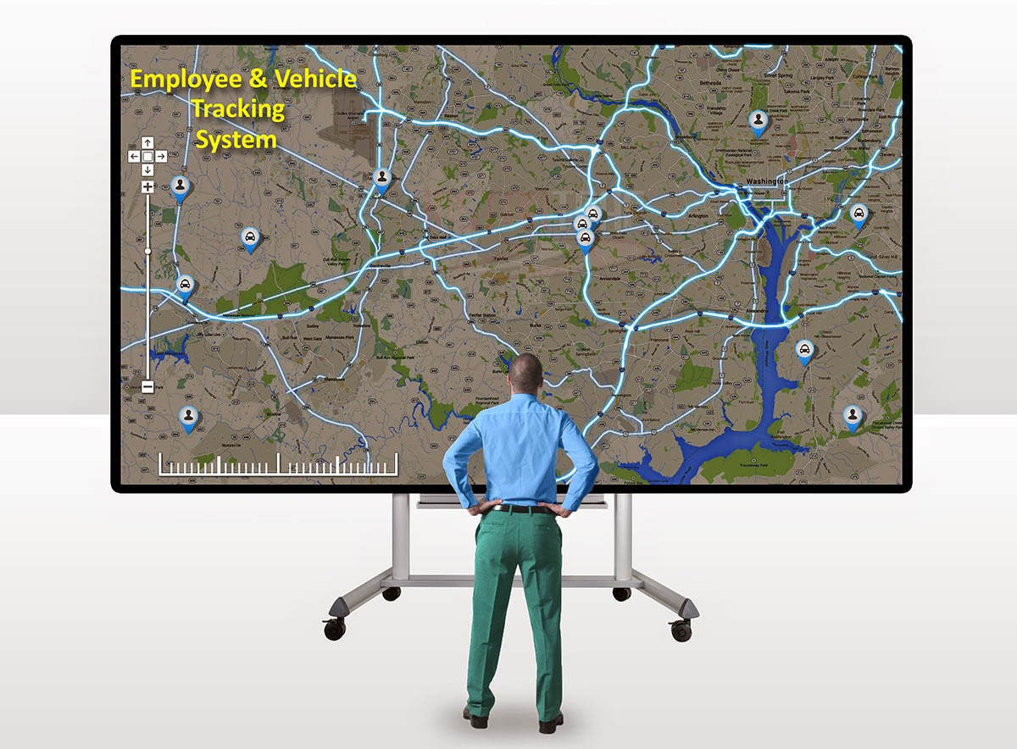

**Spoter Employee Tracking System** *(Android based)* is a comprehensive, Employee monitoring, management solution. It’s an effective low cost operation for managers of remote teams to ensure that their employees in the field are working to their fullest potential. Without a means of tracking their activities, managers are forced to do a lot of guessing about what employees are doing throughout the course of a day. Spoter Employee Tracking System enable’s managers to monitor their employees’ activities, as well as time spent visiting clients and on the road.

In addition, it also enhances effective monitoring and control of personnel. We, Spoter is an advanced Monitoring System with management capabilities that offers much more features than a standard GPS Tracking system at comparable, or in most cases lower cost. The system is backed by technicians and engineers with the ability to customize expand and successfully deploy it to virtually any application. Let’s explore some of the benefits that come from using our software.

We provide a location-based service that runs as an app on employee Smartphone and is administered by a manager from a browser-based Web tool. Simply put, in addition to other features like time tracking and fleet logistics, you can get where your employees are, where they’ve been and where they should be next. The goal is to make businesses more efficient through smarter dispatching, which should hopefully mean faster driving routes, better customer service and fuel savings. And yes, to also help businesses keep tabs on employee productivity.

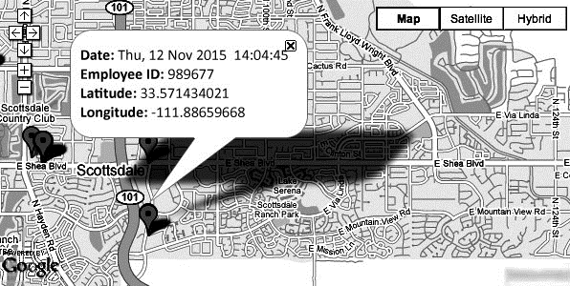

* Administrator’s can see where all workers are, if they are on schedule and can dispatch the closest worker to a certain job
* You can give clients accurate and complete information about their product delivery or when a technician will arrive at their location
* Employees can receive turn-by-turn driving directions to find the best way to the client or to locate nearest restaurant or gas station
* The apps can serve as a communication channel saving companies a lot on phone bills
* Employees have to fill less paper as they can use the app to clock in or clock out for time-card purposes or give customers forms and other papers to sign digitally. There is also the possibility to track time automatically depending on location, making it easier for the employee to see the time spent at each client.
* You can setup certain alerts when employees are entering or leaving an area using geofencing

**Businesses that are already benefiting from Spoter** **Employee** **Tracking** **System include construction, logistics, delivery, field services, fleet leasing, utilities, food and beverage, oil and many more.**

**PRICING:**

**Subscription Charges: Rs. 2,000/-** *(per employee)*

*Validity: 1 Year*

**Renewal Charges: Rs. 2,000/-** *(per employee)*

*Validity: 1 Year*

**Note:**

1. Charges excluding Data charges.
2. Approx Data consumption: 200MB per month.

In conclusion, employee location tracking apps offer a lot of benefits and if they are properly deployed can provide a big productivity boost.

Please feel free to share your queries and suggestions with us…

Thanks and Regards.

**KARUNESHKUMAR ZAVERI**.

*Distributor* – **SPOTER SURAT**

**Date:**

**Time:**